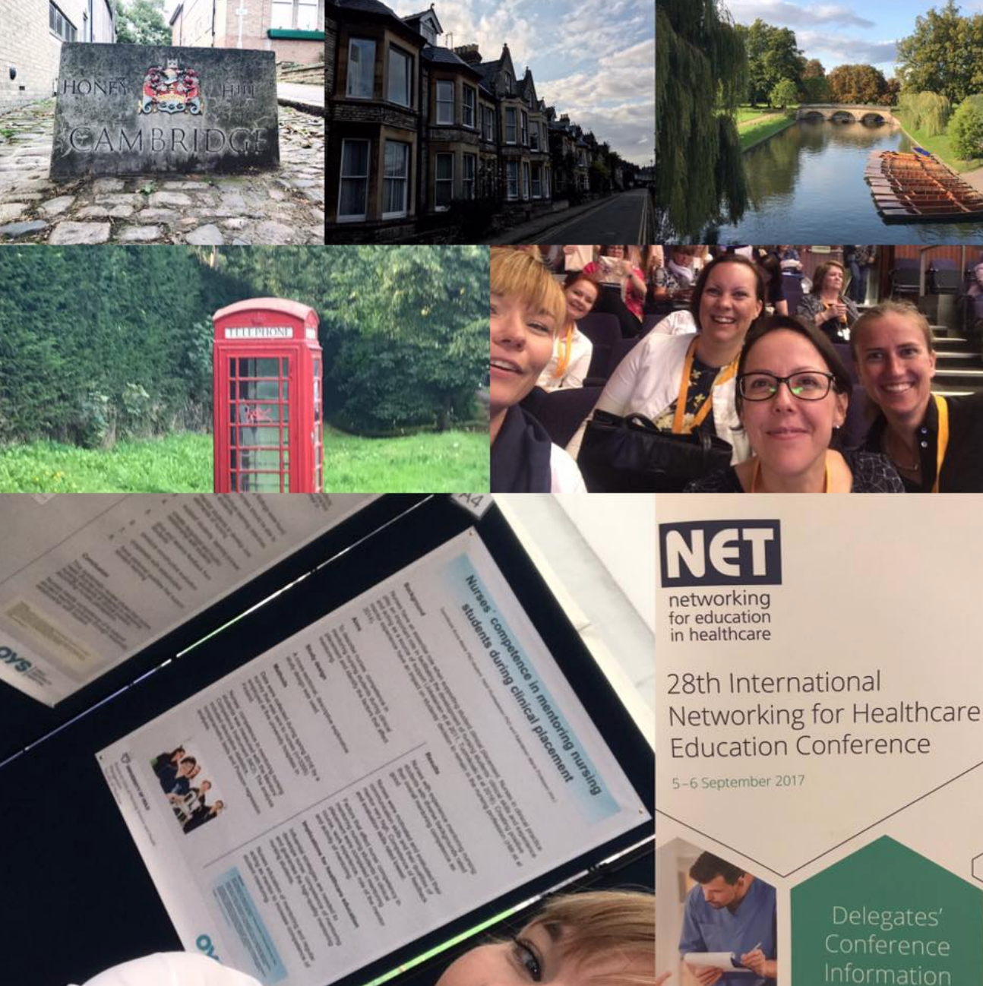

Five things you can take away from a healthcare education conference

In September, I attended the 28th Networking for Healthcare Education 2017 (NET) conference, which was held in Cambridge, England. I held an oral presentation at the conference on my research topic regarding mentors´ competence in mentoring culturally and linguistically diverse nursing students during clinical placement. I travelled with two of my colleagues, Annukka Tuomikoski and Kristina Mikkonen, who also held presentations.

At the end of the conference, we were asked “What are you taking away from the conference”? On our flight back to Finland, Annukka, Kristina and I discussed this question and summarized our thoughts into five themes.

Here are five things that you can take away from a healthcare education conference.

- Networking
The importance of multidisciplinary networking in healthcare education cannot be emphasized enough. It is so important that healthcare professionals, educators and researchers share knowledge and learn from each other. Healthcare practice and education can develop through discussions, interactions and active collaboration.

- Dissemination of evidence-based knowledge
Conferences are an excellent way to spread evidence-based knowledge on current best practices in healthcare education. Knowledge can also be spread through the publishing of articles, providing training or through spreading knowledge on social media. As new Twitter users, we were all positively surprised on how convenient it is to discuss issues related to the conference through Twitter.

- Importance of developing healthcare education related research
Healthcare education and practice are impacted by the rapidly changing world, which stimulates the need for continuous assessment and development of healthcare education practices. At the conference, several presentations were held on national and international healthcare education related projects. It is so important for researchers to continue to conduct robust research using diverse research methods.

- Support of healthcare students´ learning and professional development
The highlight of the various presentations at the conference evolved around supporting healthcare students´ in their learning process and professional development. Several innovative projects were presented in which new types of learning and evaluation methods had been integrated into curriculums.

- To have fun and enjoy healthcare education conferences
Attending a conference can be a fun and relaxing experience. I would like to encourage all healthcare professionals to attend conferences within their field. It is important that healthcare professionals, educators and researchers participate in conferences and actively present their results on research or from different projects.

As healthcare professionals, educators and researchers we travel towards one common goal: to ensure a competent future healthcare workforce.

This text is a summary. The original text has been written in Finnish and published on the Akavan sairaanhoitajat ja TAJA Ry website available through the following link.

